Insights from Graphs:

Univariate Analysis:

Countplot for Sex:

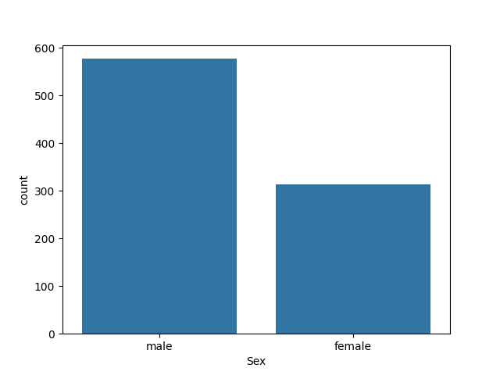

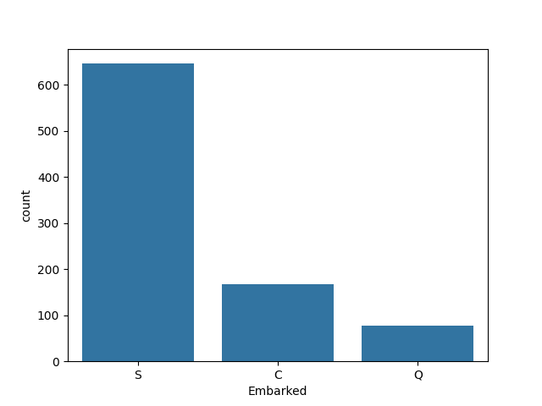Countplot for embarked:

Countplot for Passenger class:

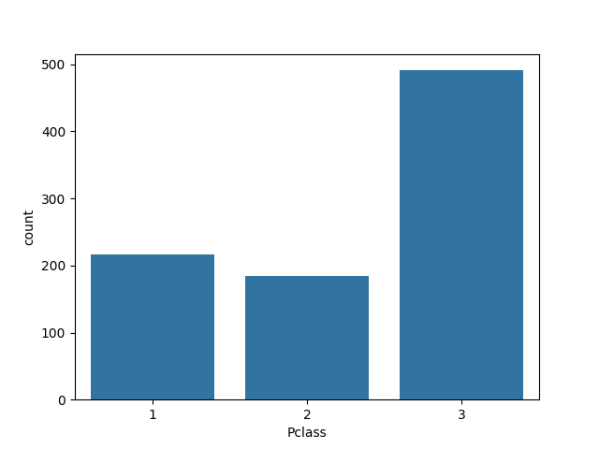

Countplot for Survived: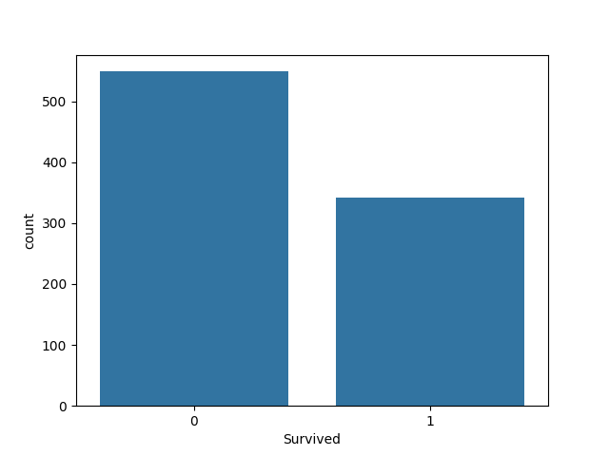

Insights:

* Male passengers where more compared to the female passengers boarded the ship.
* More number of passengers boarded the ship from Southampton port and less people boarded from Queenstown port.
* Large number of passengers reserved 3rd class for travelling while 2nd class was the least preferred class.
* Morethan 500 people who boarded the ship lost their lives while around 330 people survived.

Histogram and KDE plots:

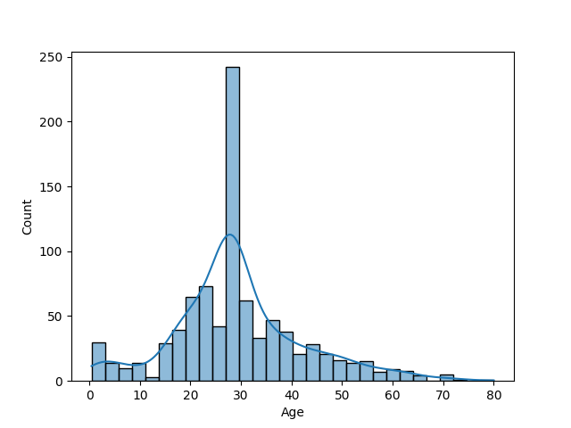

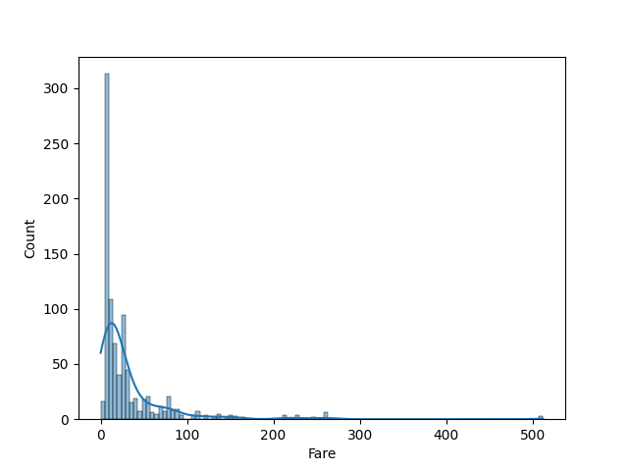

Insights:

* Passengers age data is normal distributed.
* Most people preferred 3rd class which is cheaper in fare compared to other two classes.

Bivariate Analysis:

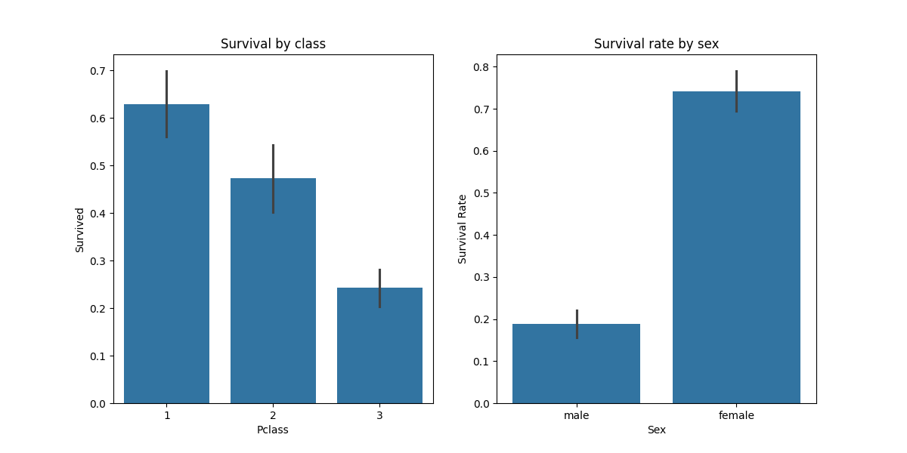Barplots:

Insights:

* Survival rate for people in 1st class is more compared to other two classes.
* Survival rate for female passengers is high compared to male passengers.

Scatter Plot:

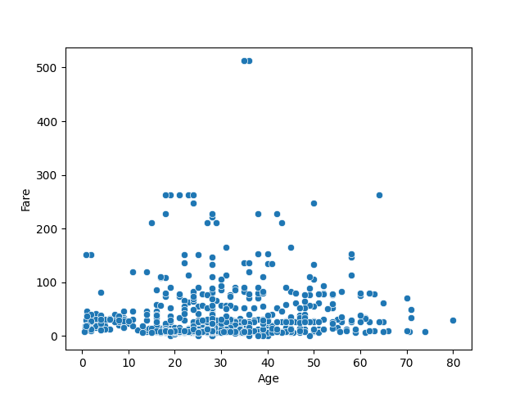

Insights:

* There is no relationship between age and fare.

Multivariate Analysis:

Barplot:

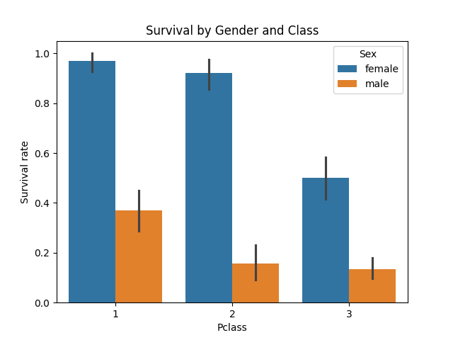

Insights:

In all the three classes the survival rate for female passengers is higher compared to male passengers.

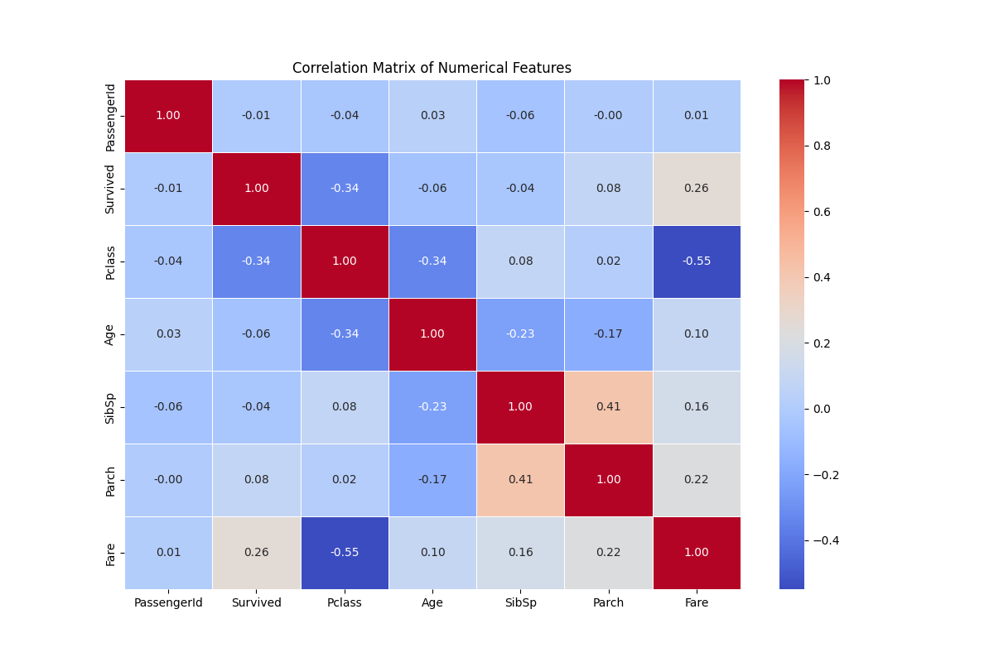Corelation matrix Heatmap:

Feature Extraction:

* Titles from the Name column is extracted and separate column for title is created.
* The Fare is split into three ranges low, medium and high and a feature with name Fare_range is created.
* The new Family size feature is created:

FamilySize = SibSp + Parch + 1.